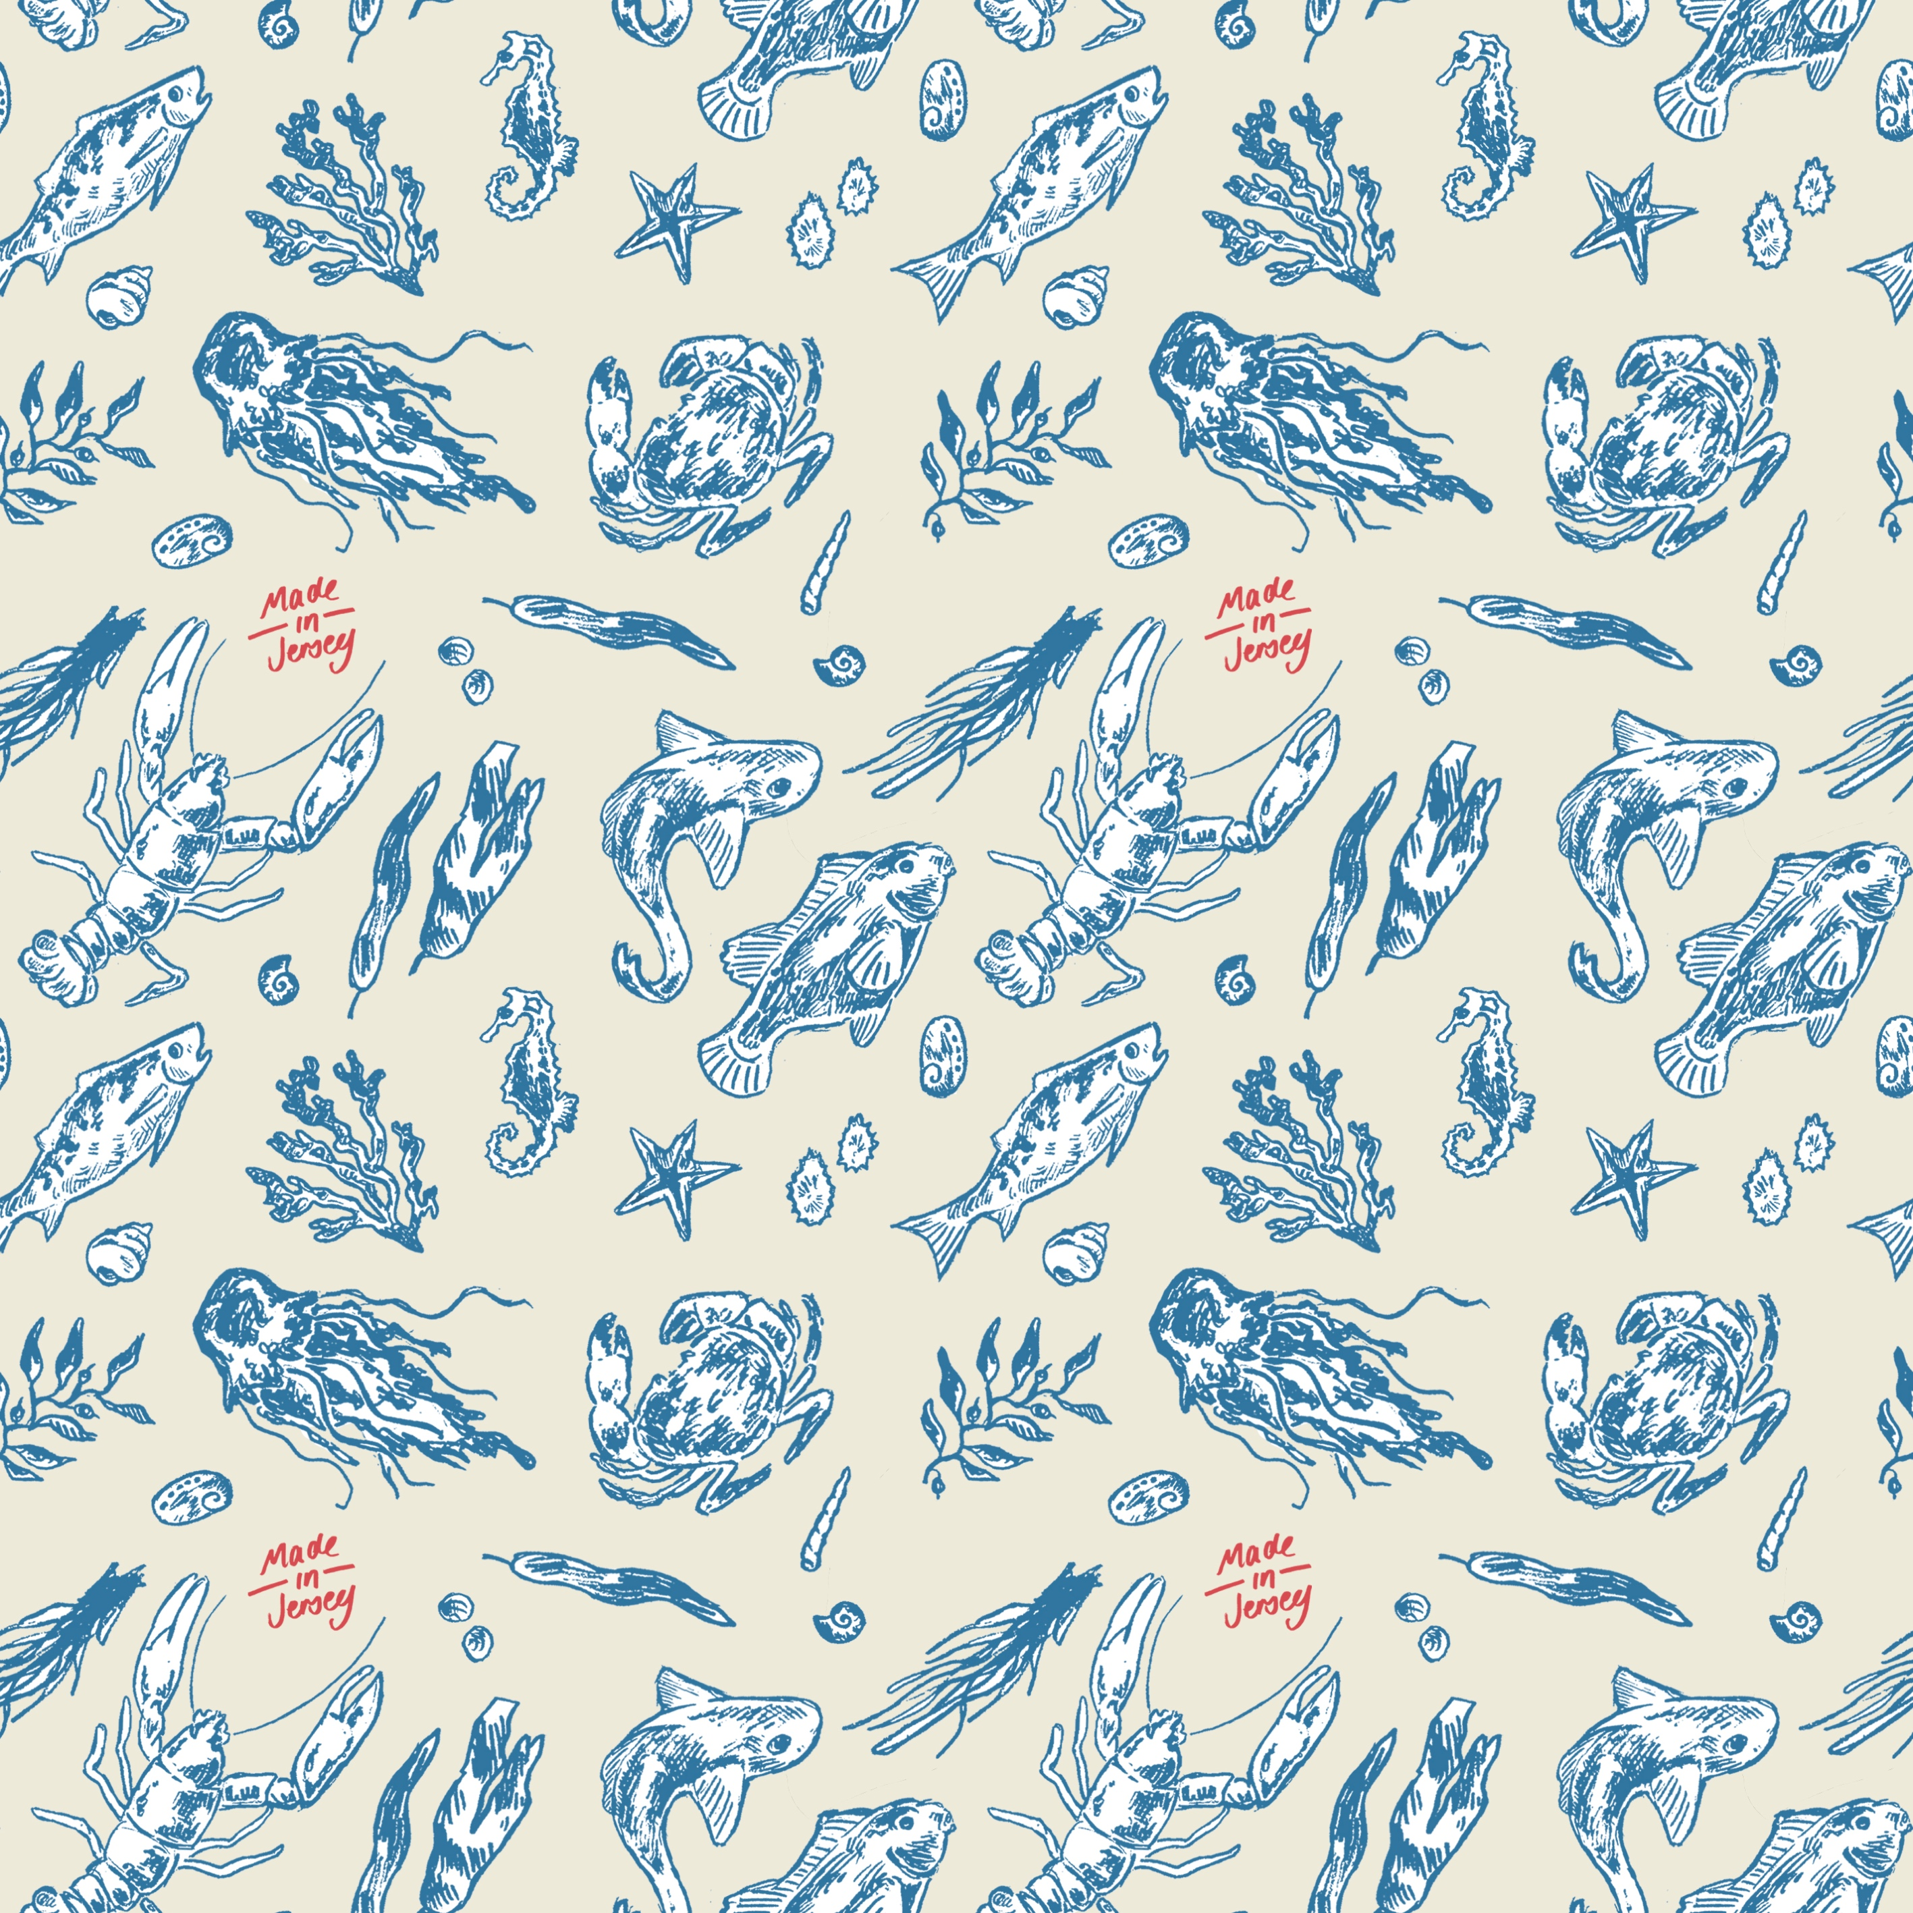
I th Edvard Munch enthusiast. Inspired by details and concepts

RochelleMerhet
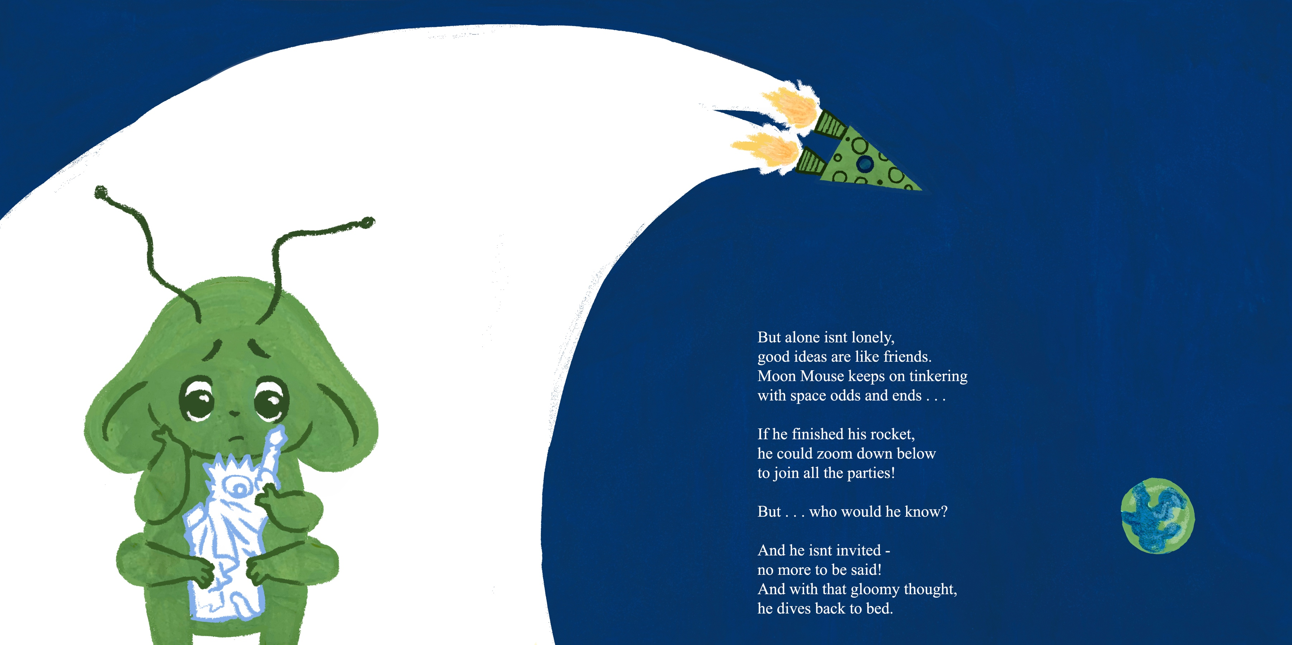
01:
Carmelite Competition: MoonMouse
This was for the Carmelite competition. I used a variety of painted textures and ten combined them into photoshop. This was a really fun project and I enjoyed making the adorable Moonmouse character. Below are a selection of client visuals for this project.
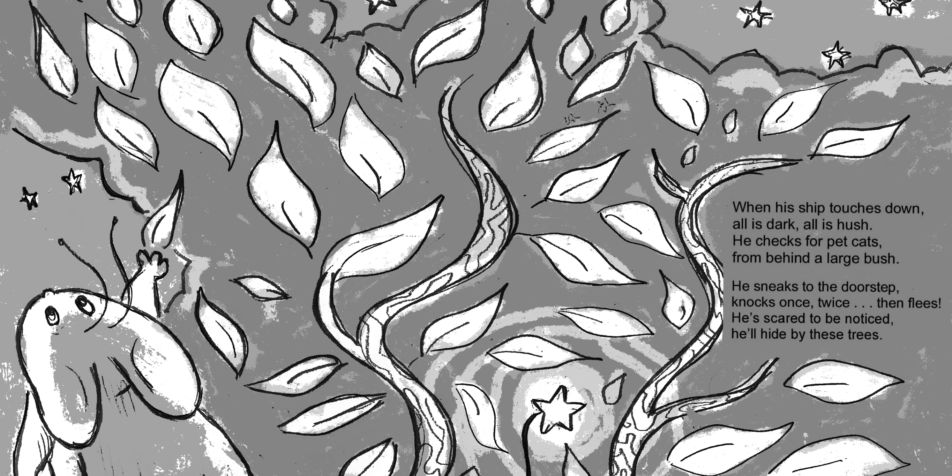
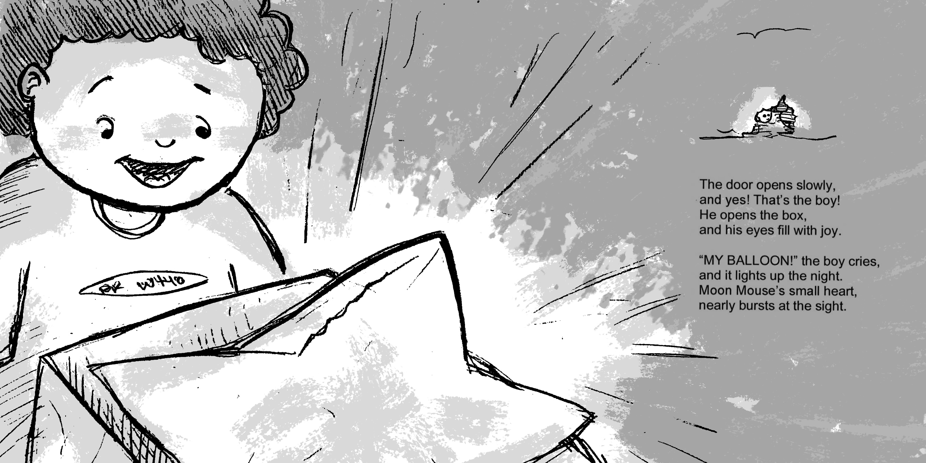
solution. Description of the brief
Description of the brief and of the
solution. Description of the brief and of
the solution. Description of the brief
and of the solution. Description of the
brief .Description of the brief and of the
solution. Description of the brief and of
the solution. solution. Of the solution
Description of the brief and of the
solution. Description of the brief
Description of the brief and of the
solution. Description of the brief and of
the solution.

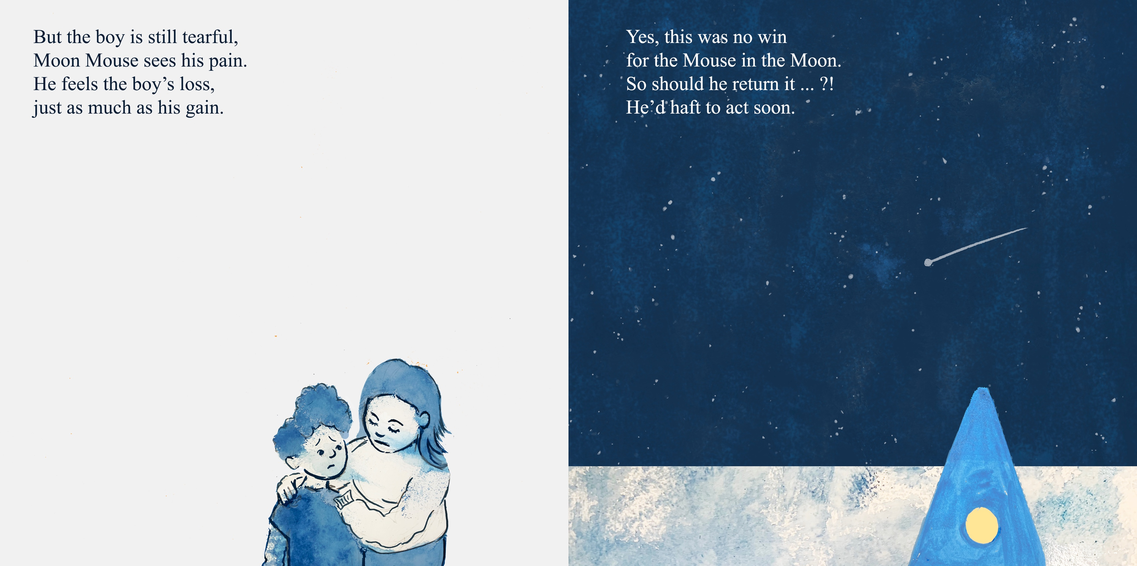

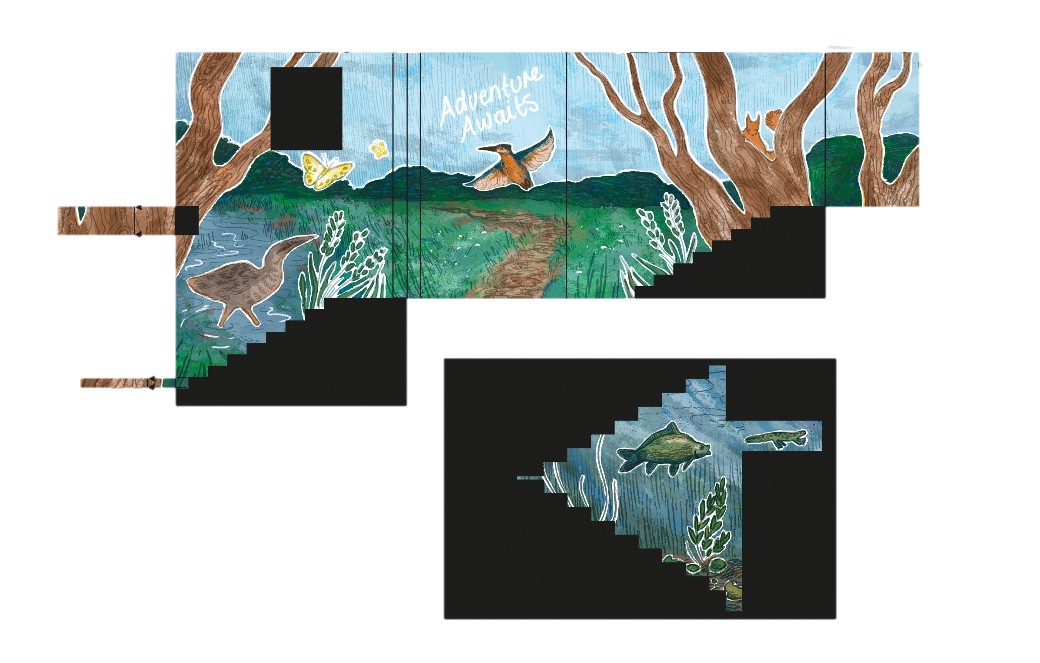
01:
Creative Title of Project
This project was to create a mural for the Lincolnshire wildlife project for their Far Ings reserve. I created the design by making a pencil drawing and then painting over the top of it in photoshop, I tried to create a design that was similar to a painting.

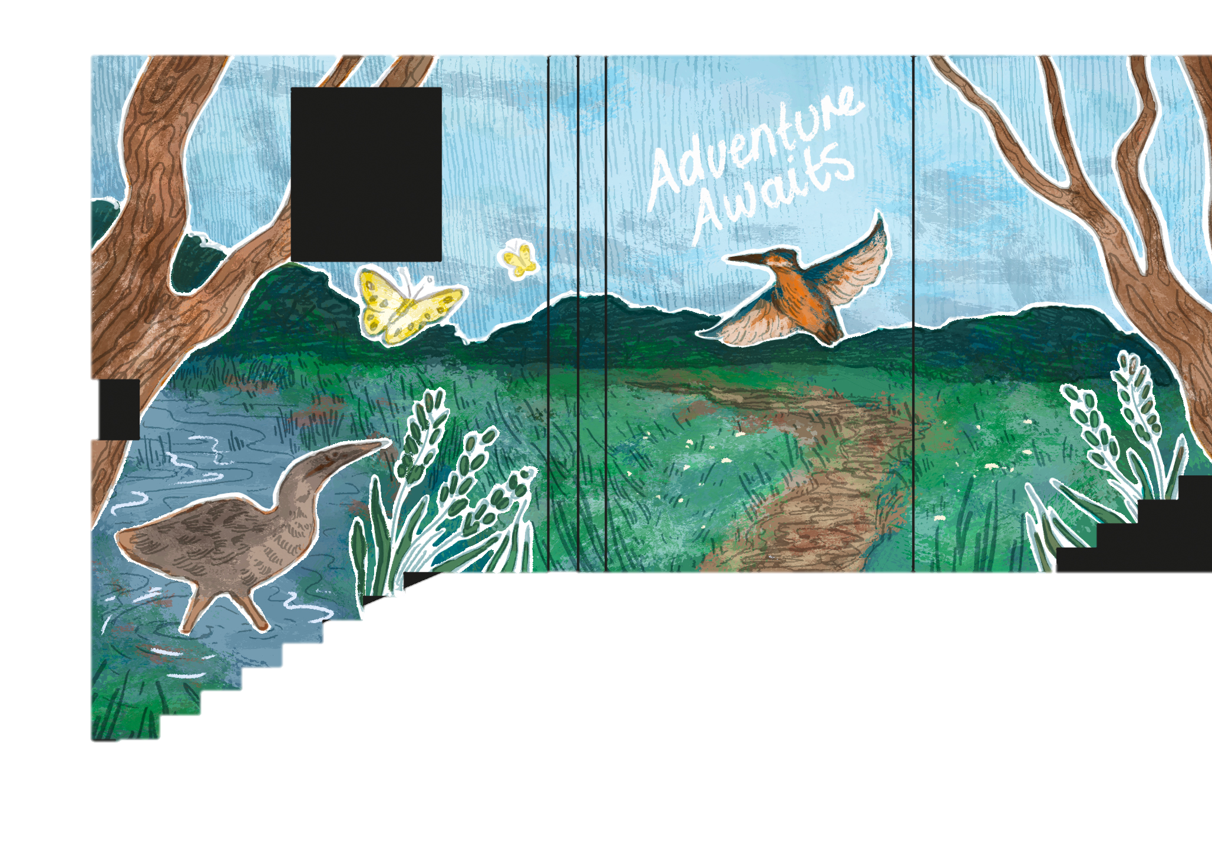

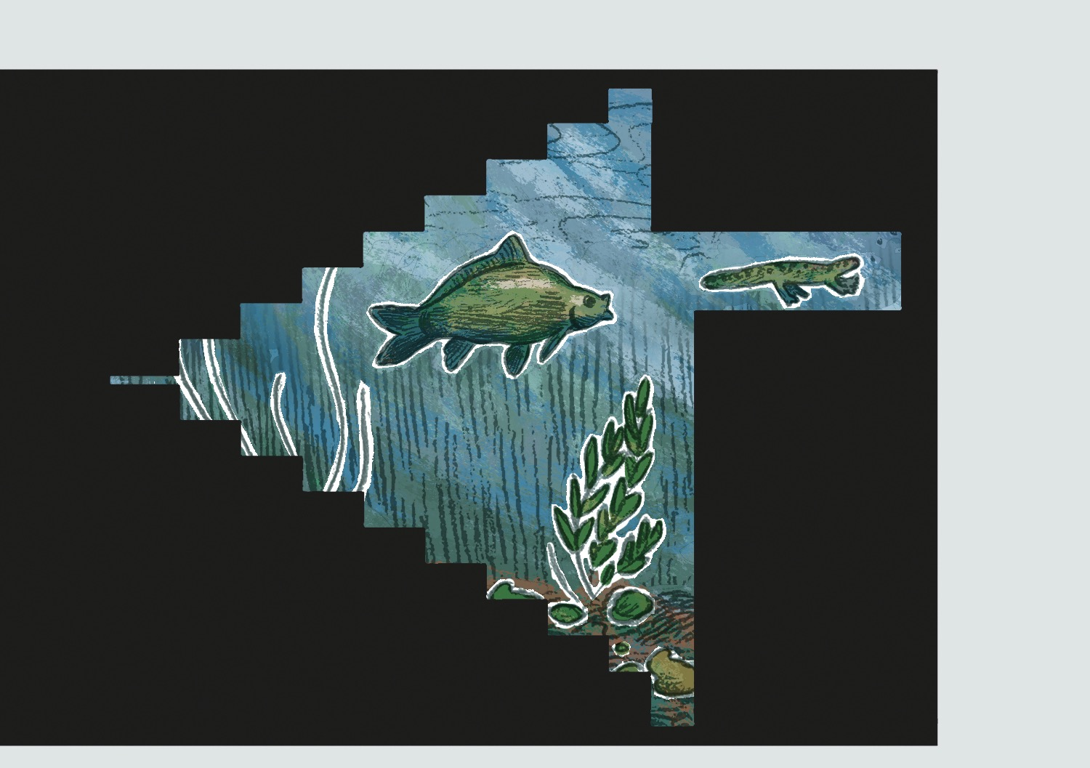

.

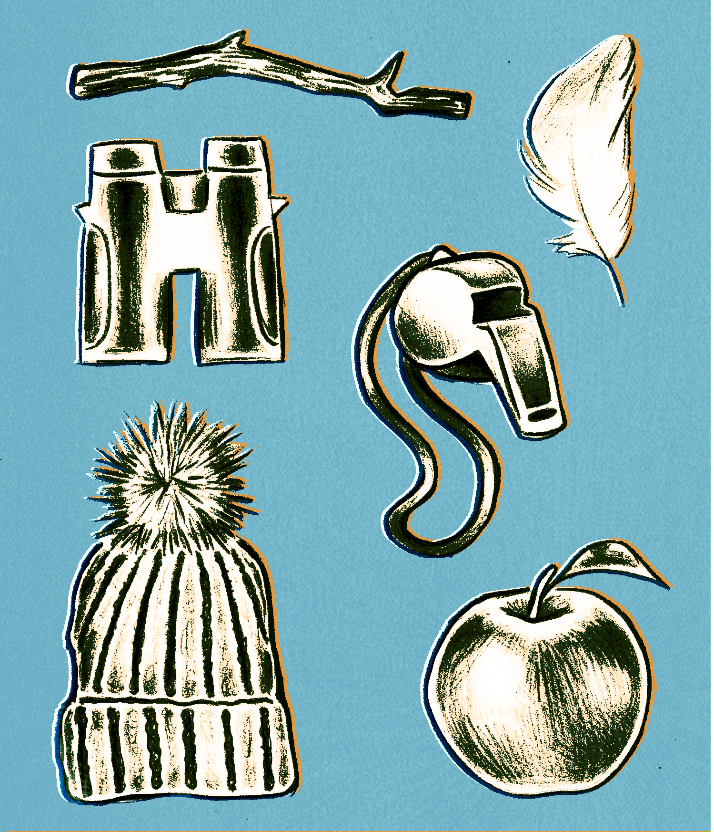
Here is an experiment for the Wildlife project, I tried
out a few different ideas before landing on the one featured
above. This was made by combining a drawing and editing
it in photoshop by adding various layers and textures.

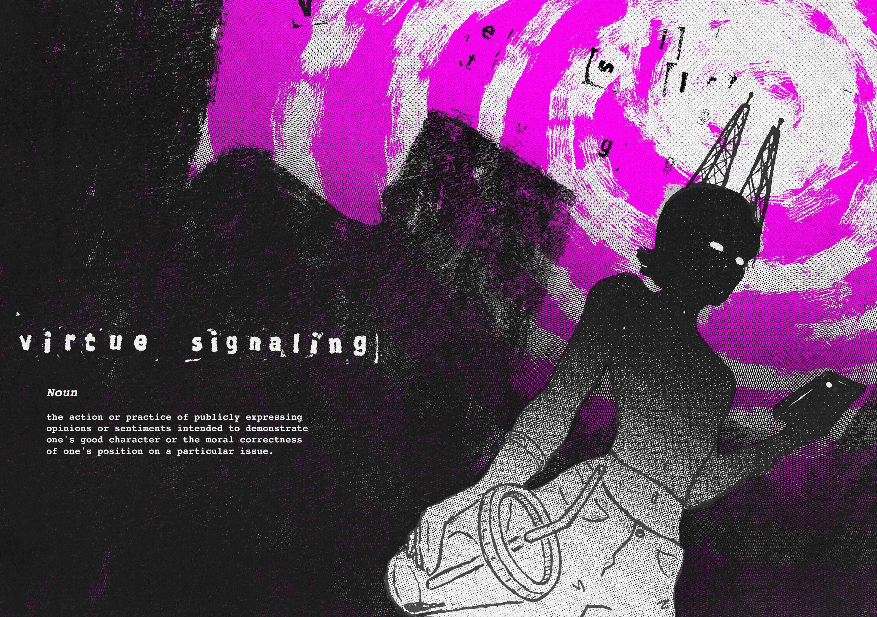
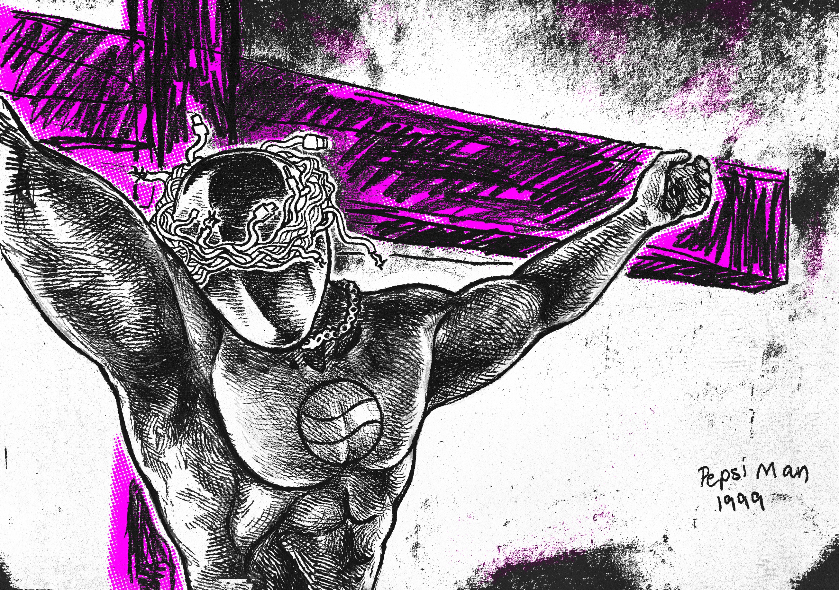
02:
Negotiated Project
This is probably my most challenging but rewarding project I have created, and also my favourite. I created a zine that explored the toxic effects of social media. I based the style off of my dissertation where I explored punk art, I was heavily inspired by the work of Raymond Pettibone and Jamie Reid. I combined drawings with photoshop to give it an edgy printed effect.
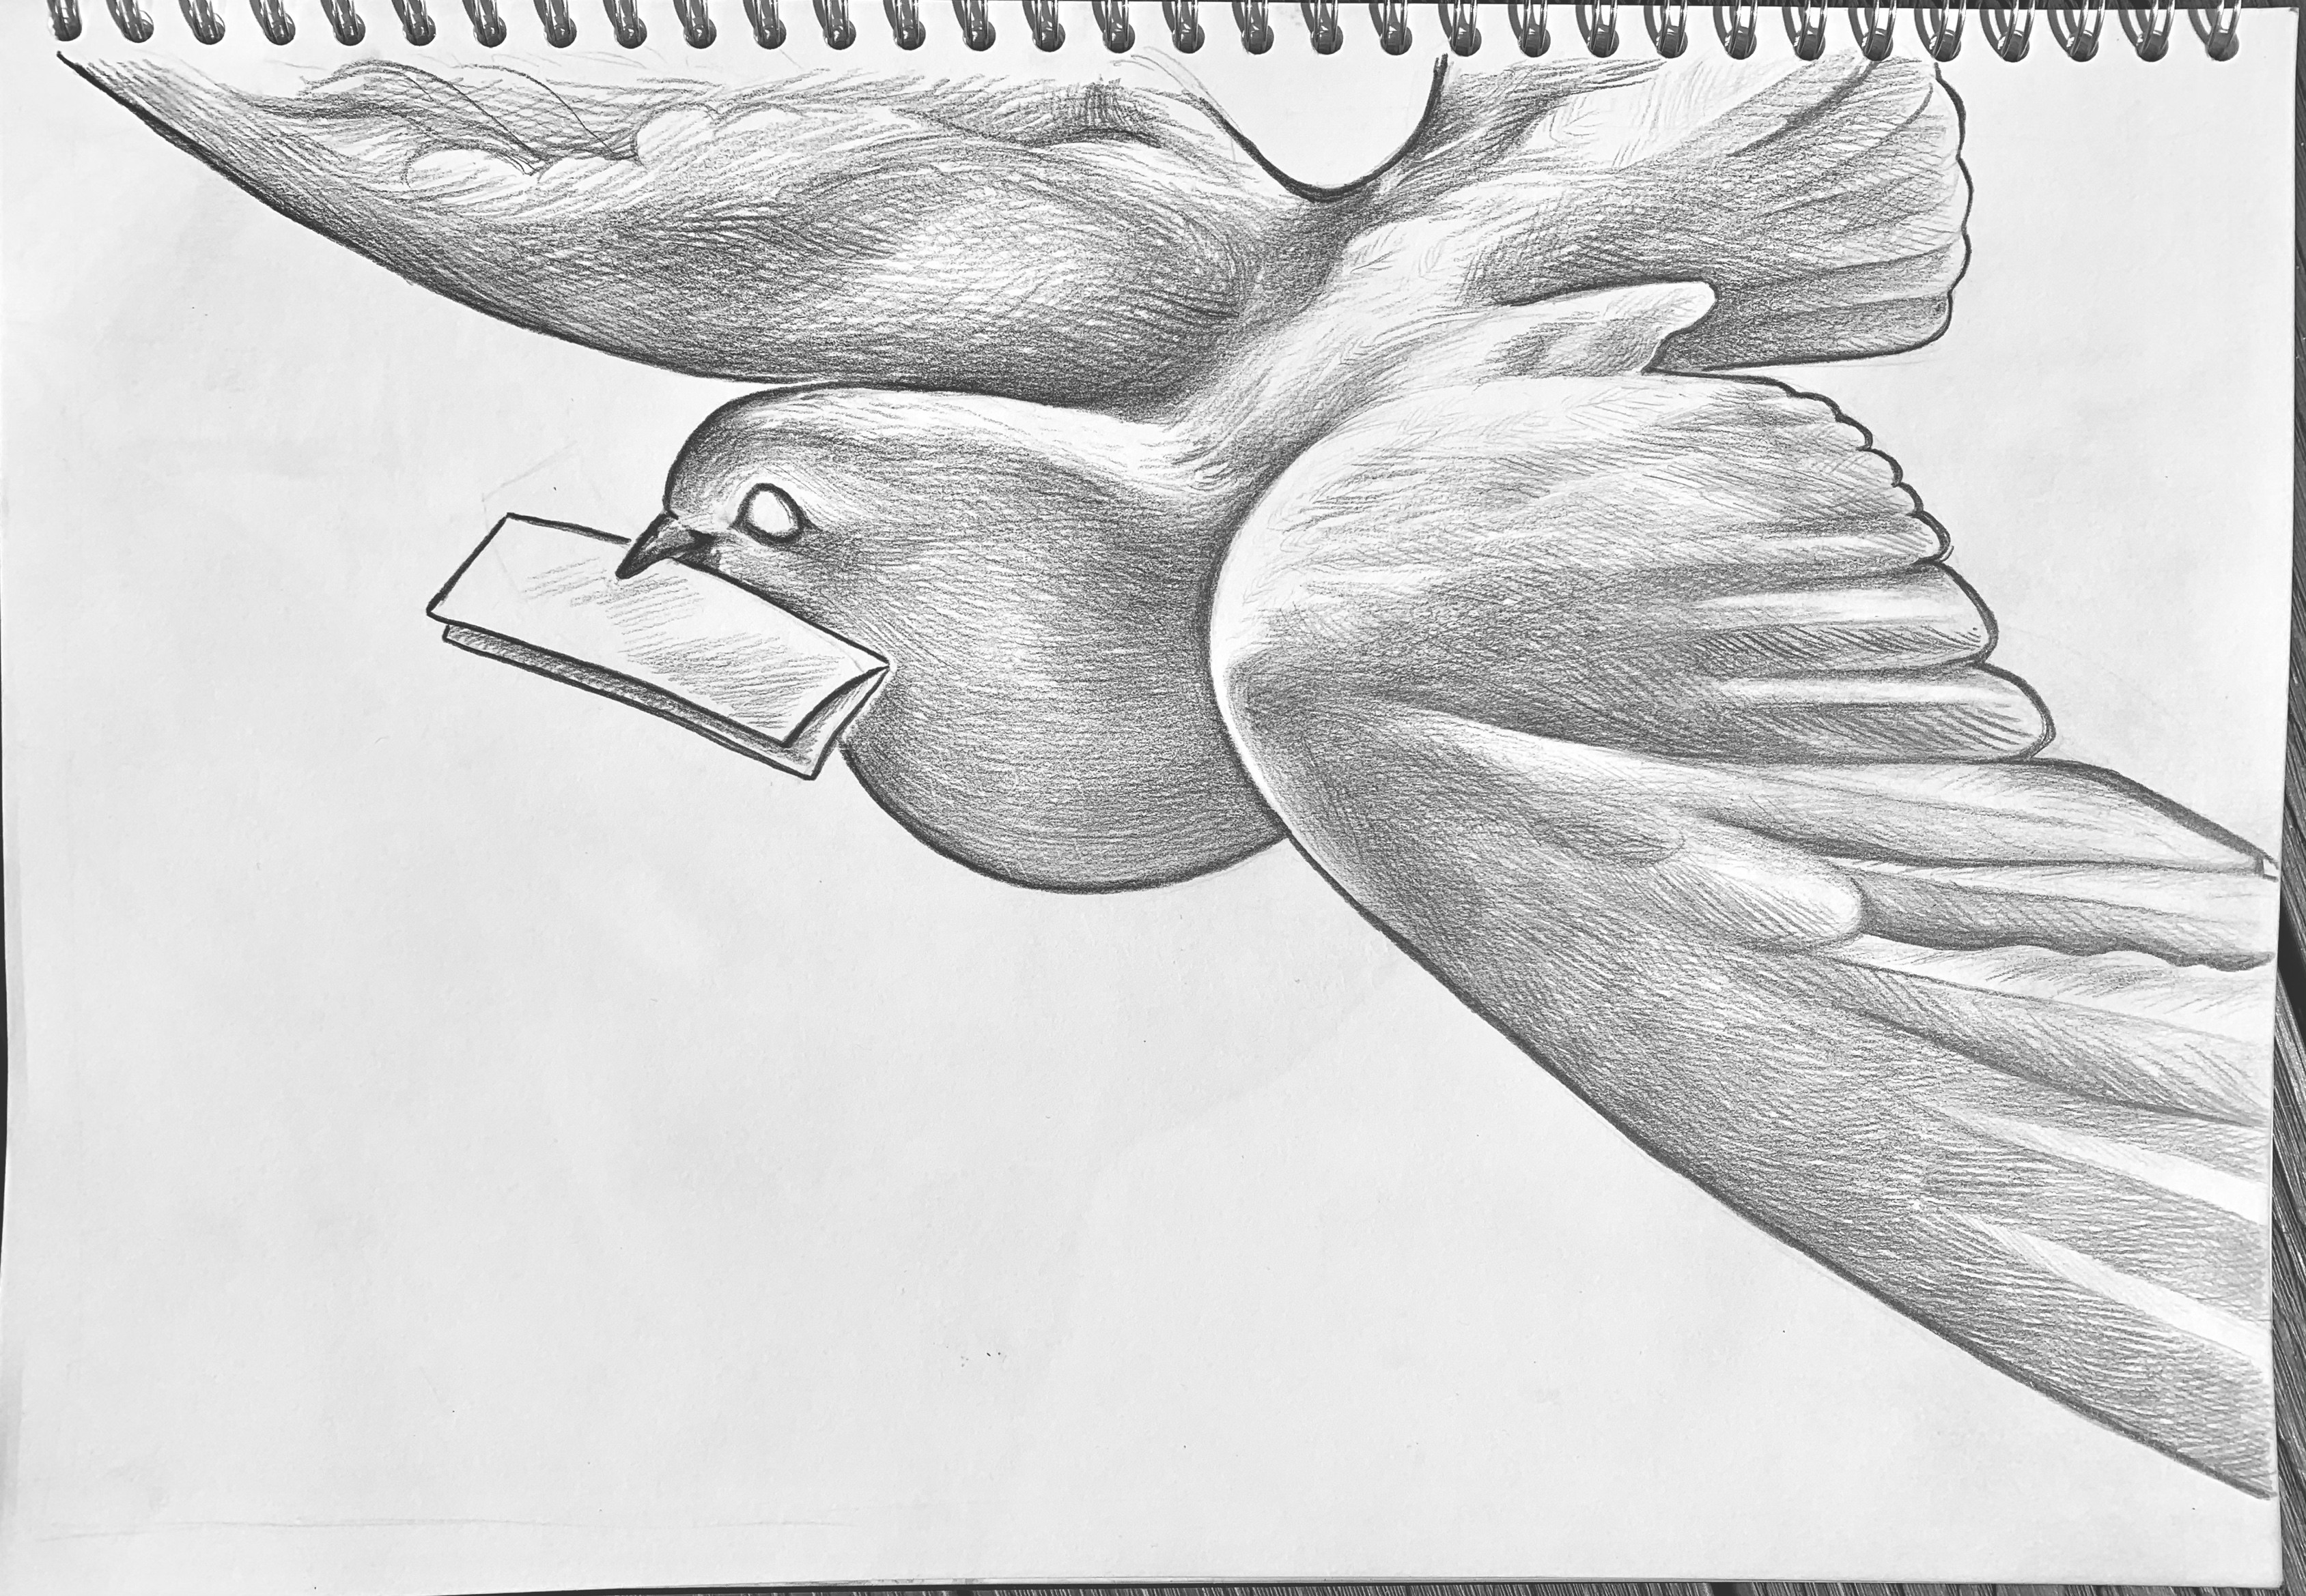

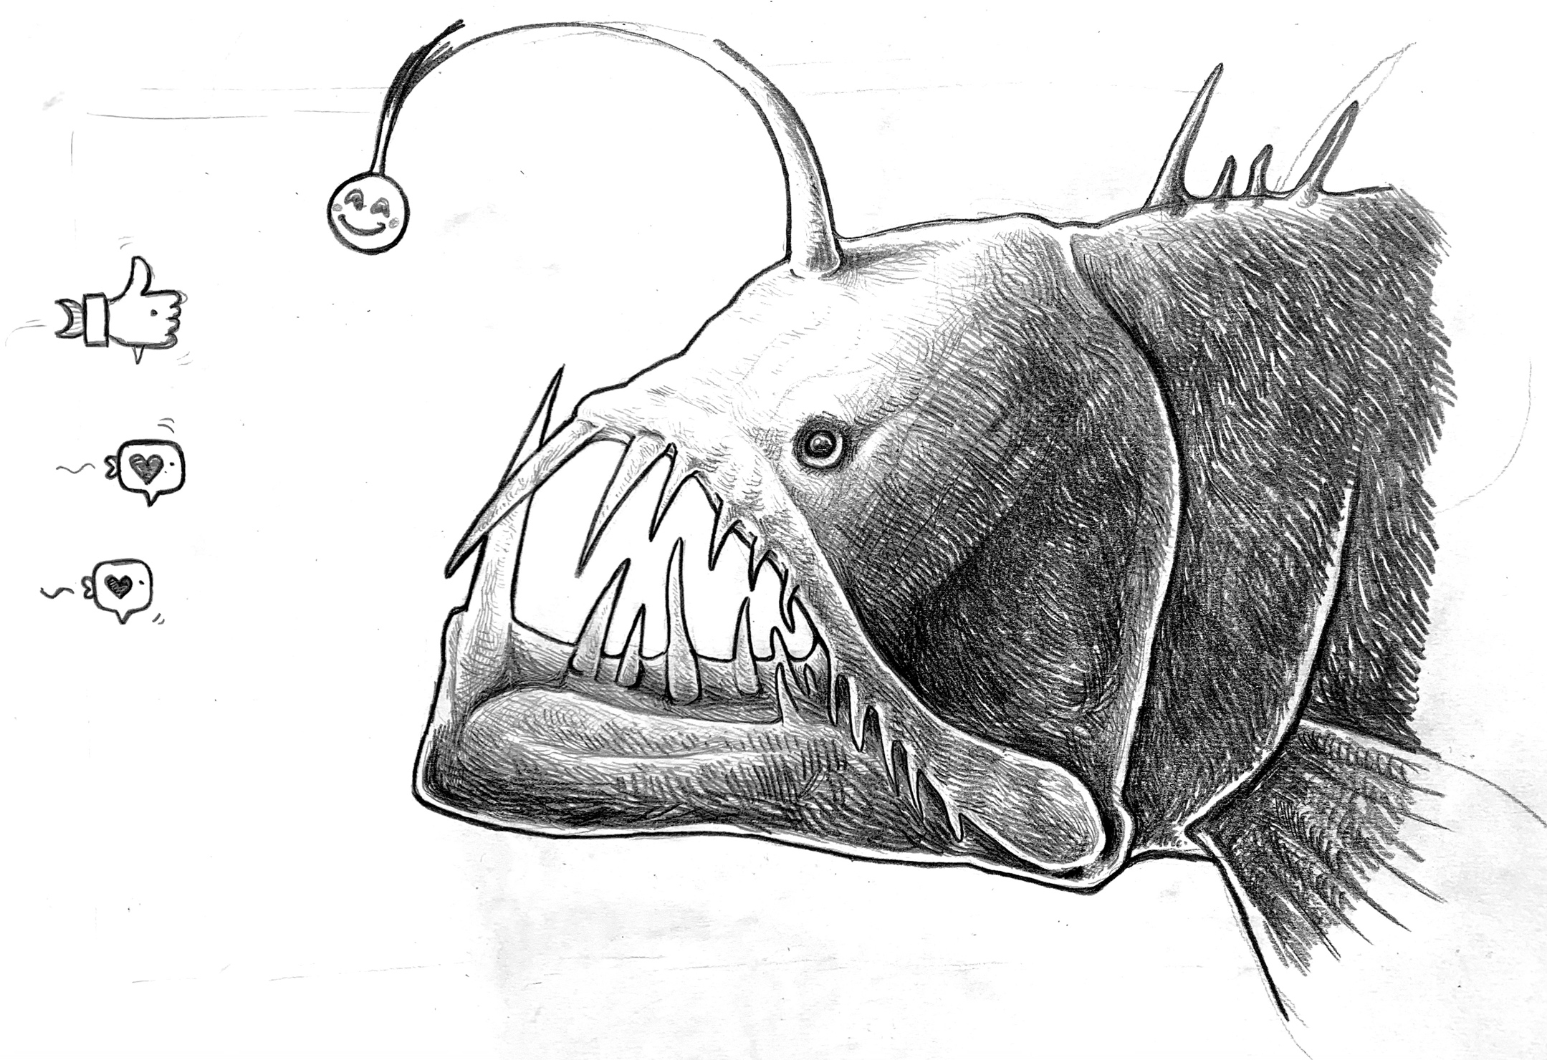

qw
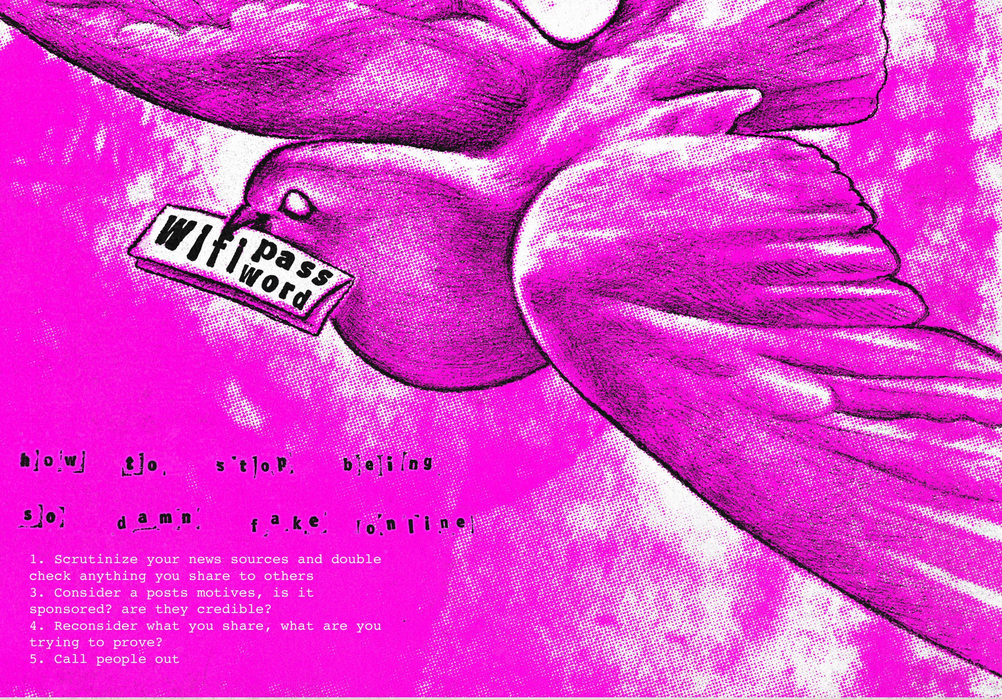
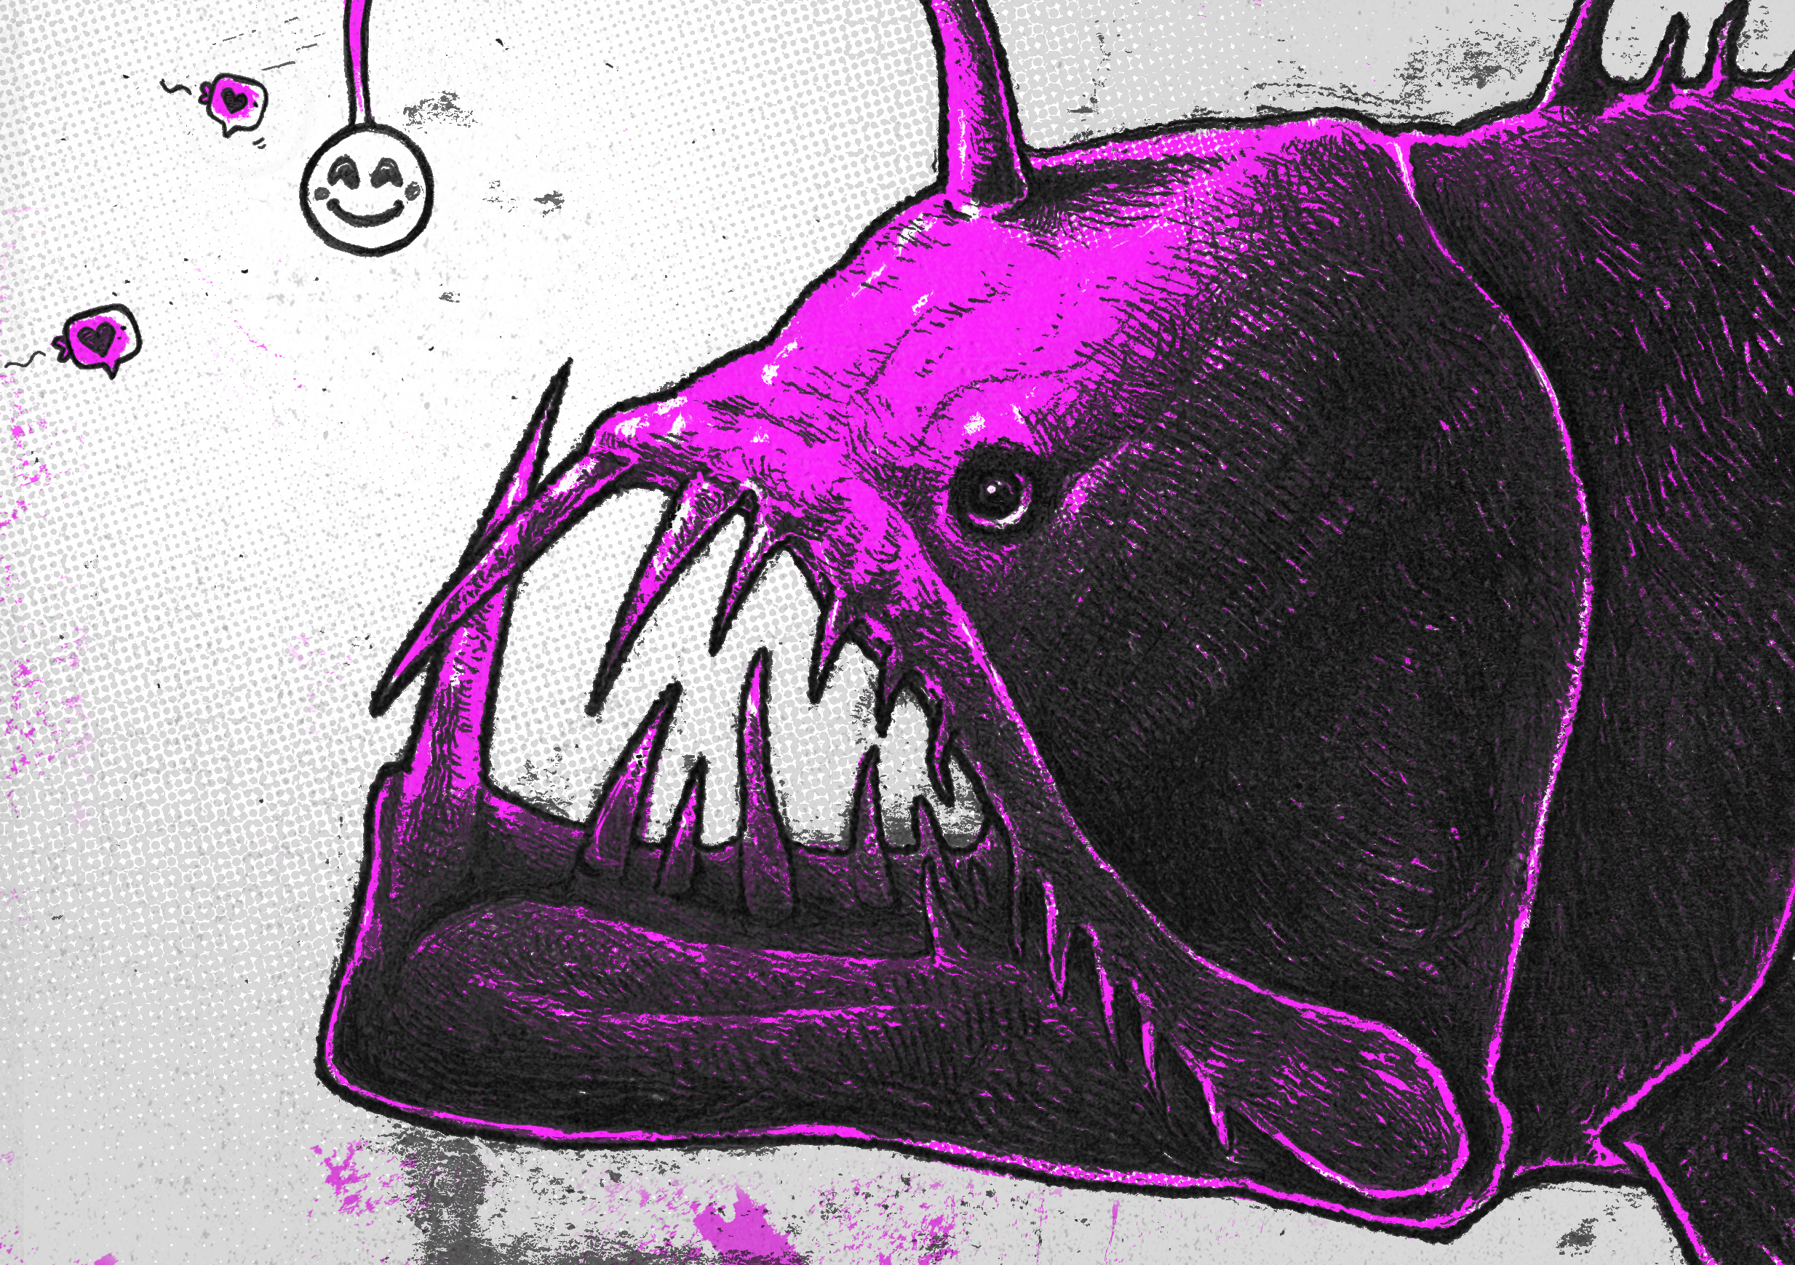

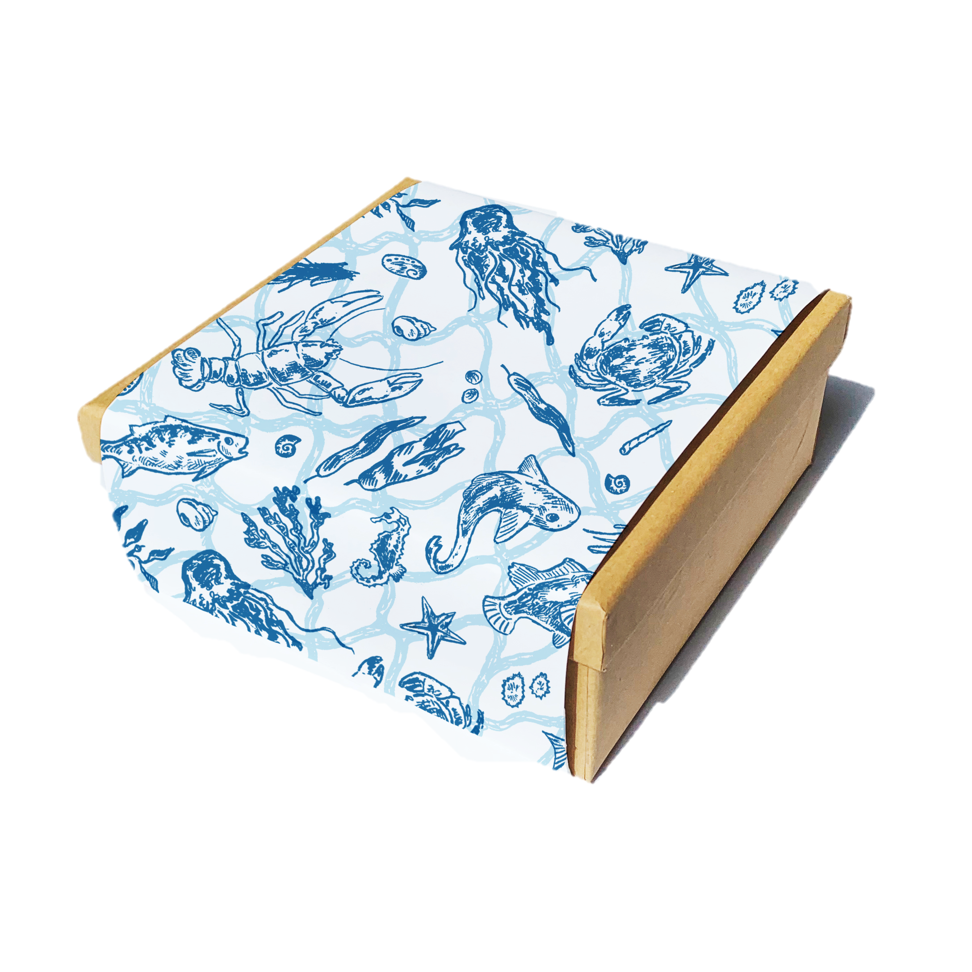

Here is a selection of self-promotional work. I decided to create a beret
as a promotional item which is accompanied by a box, featuring a design
by myself.

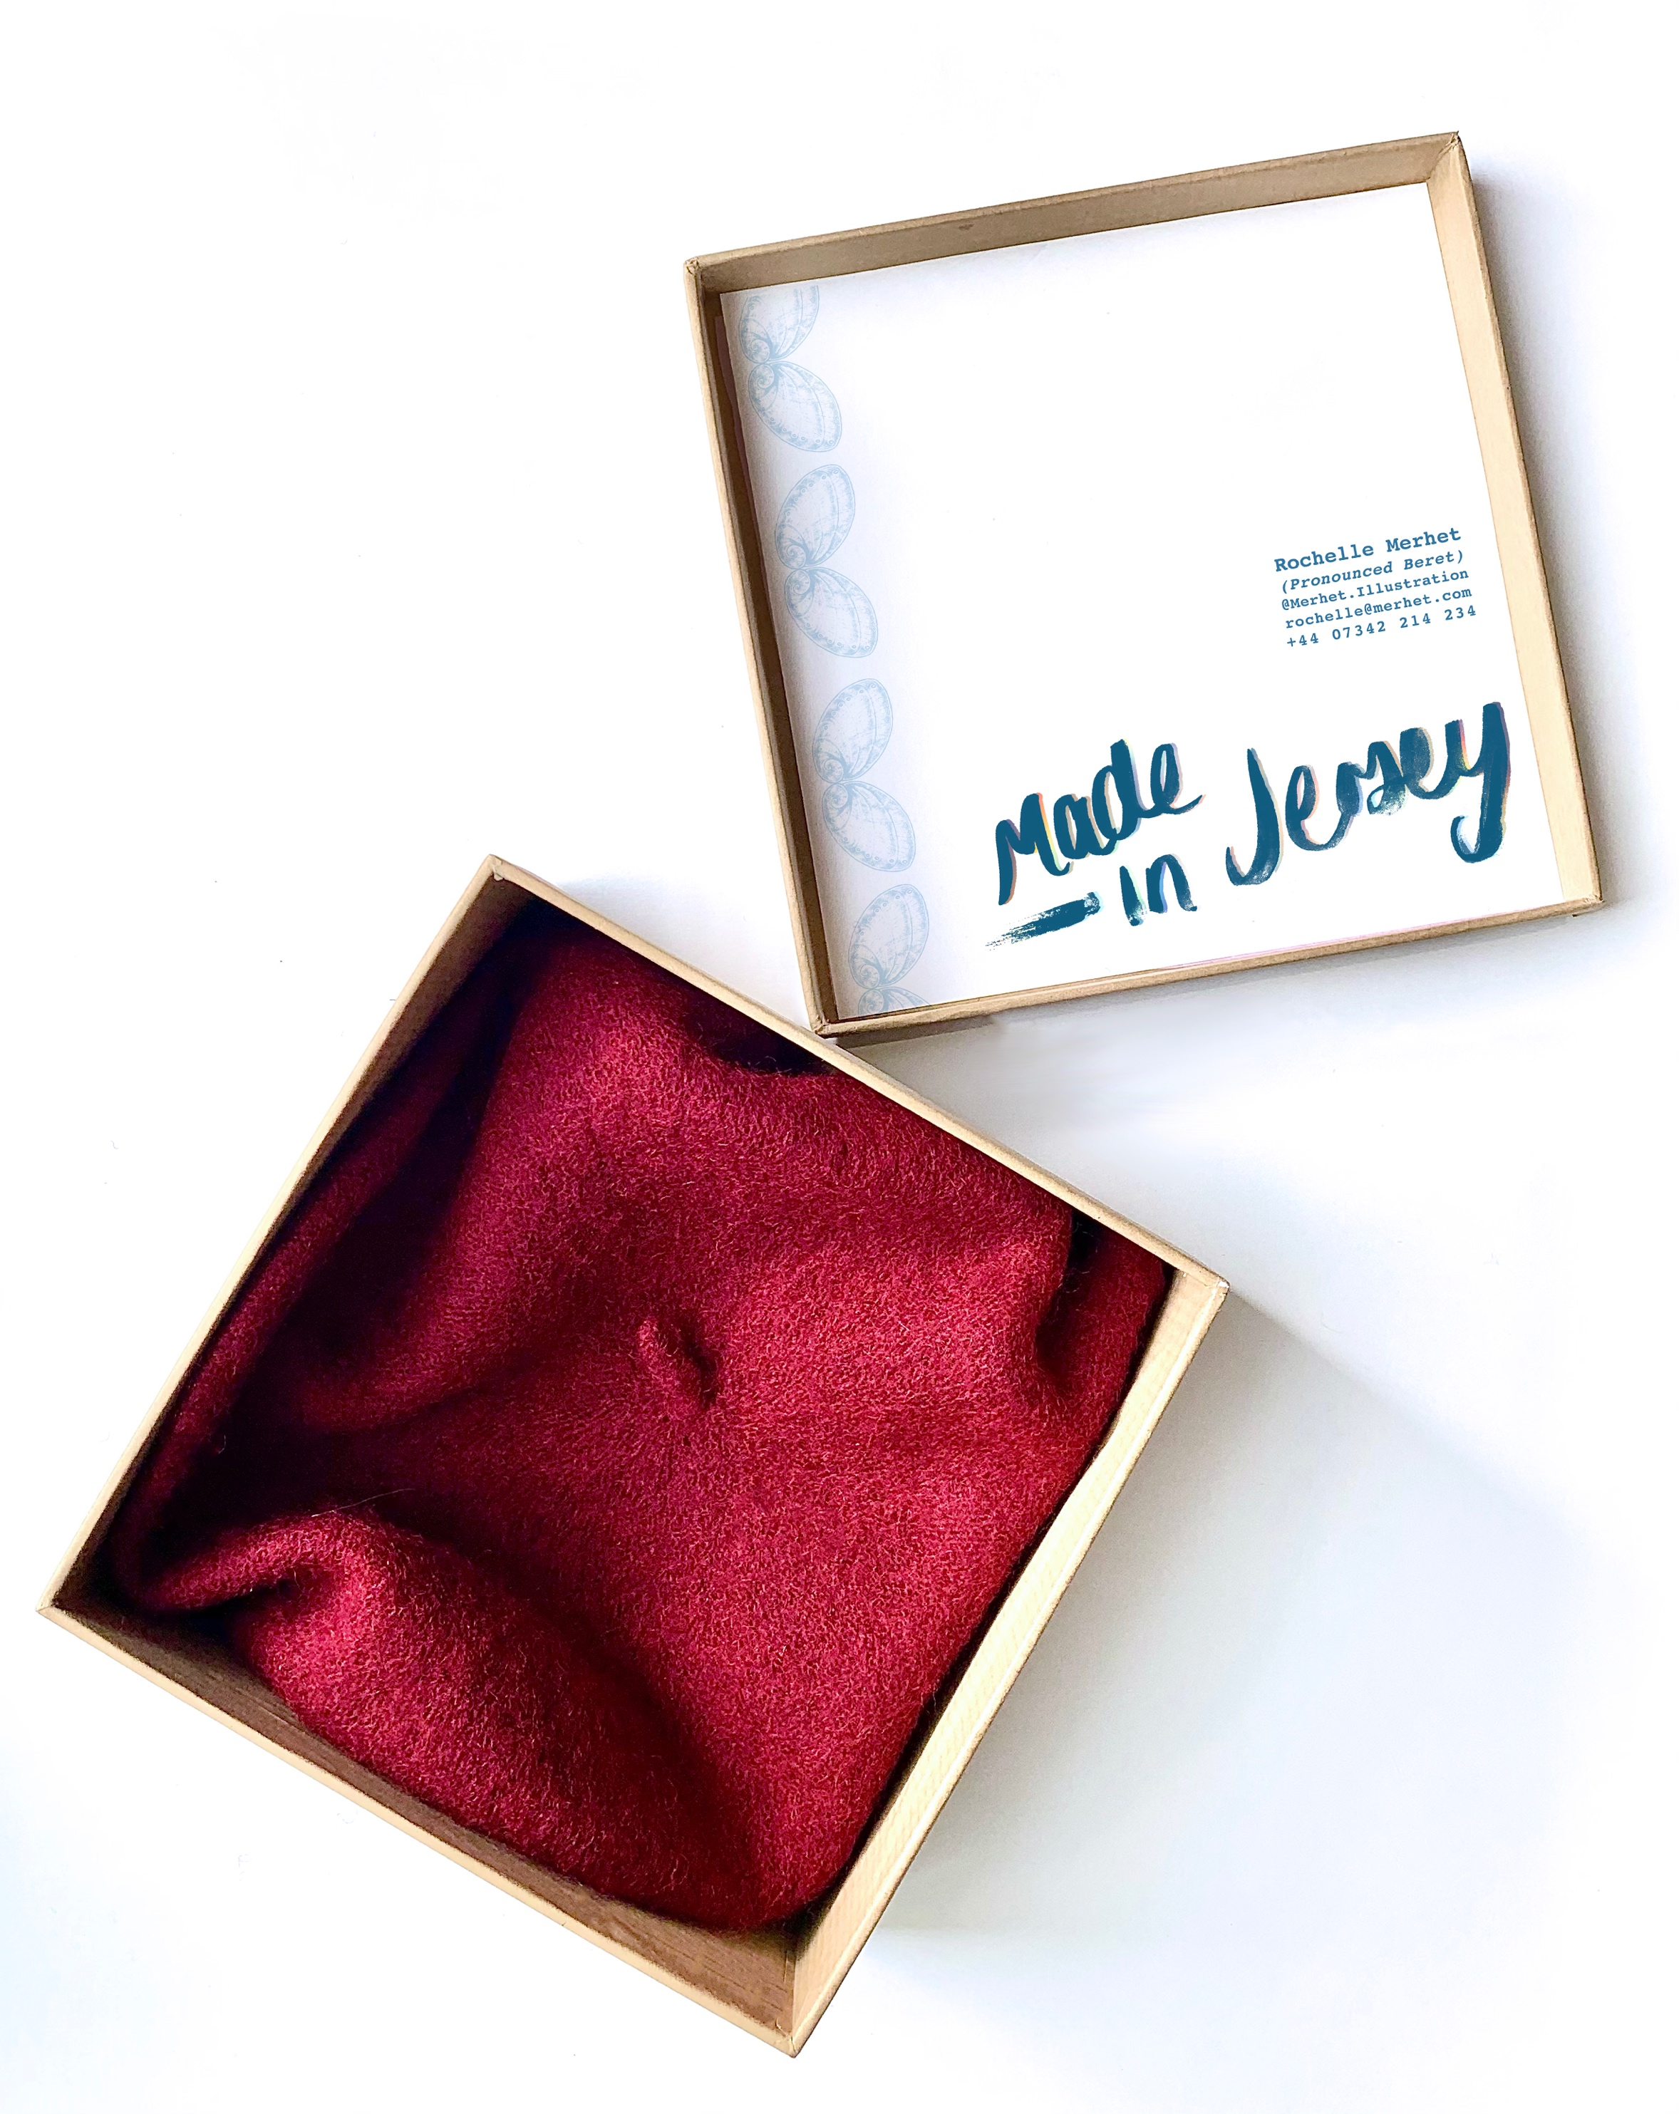
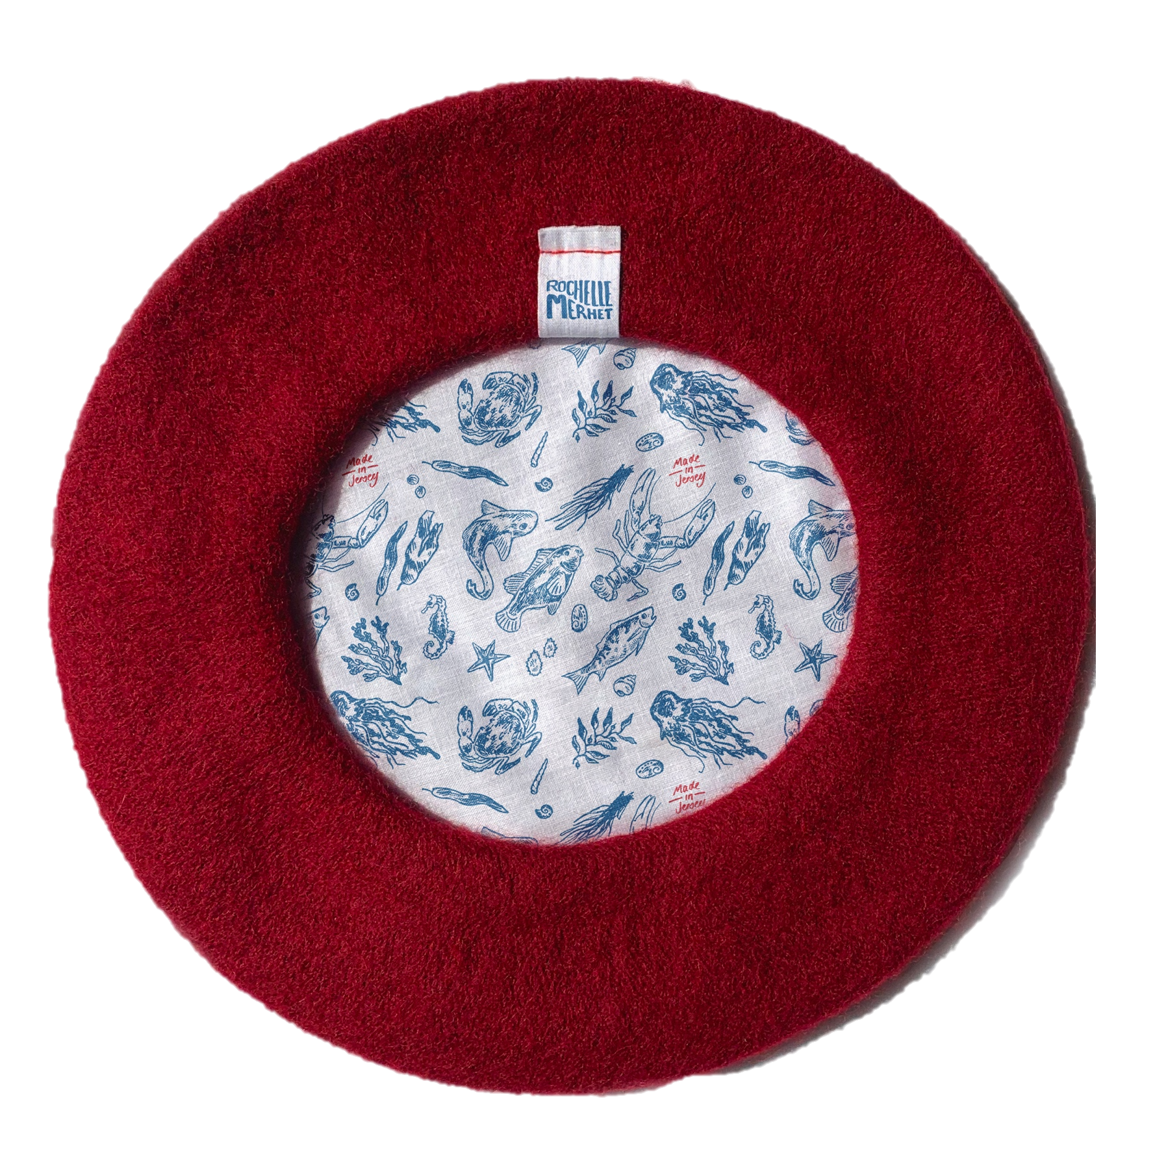

I th I themed this project around my jersey heritage. And I picked a beret as often when people ask how you pronounce my second name I tell them ‘Its pronounced beret but with an M’

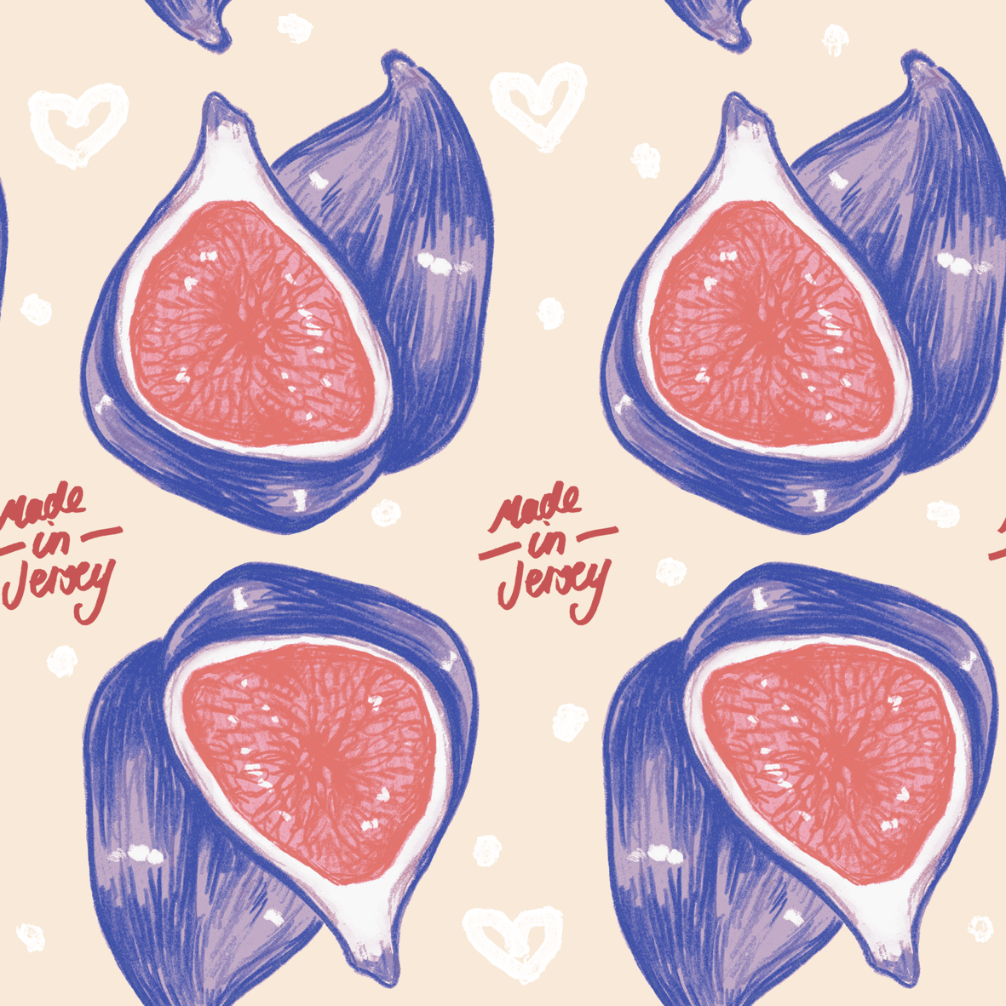
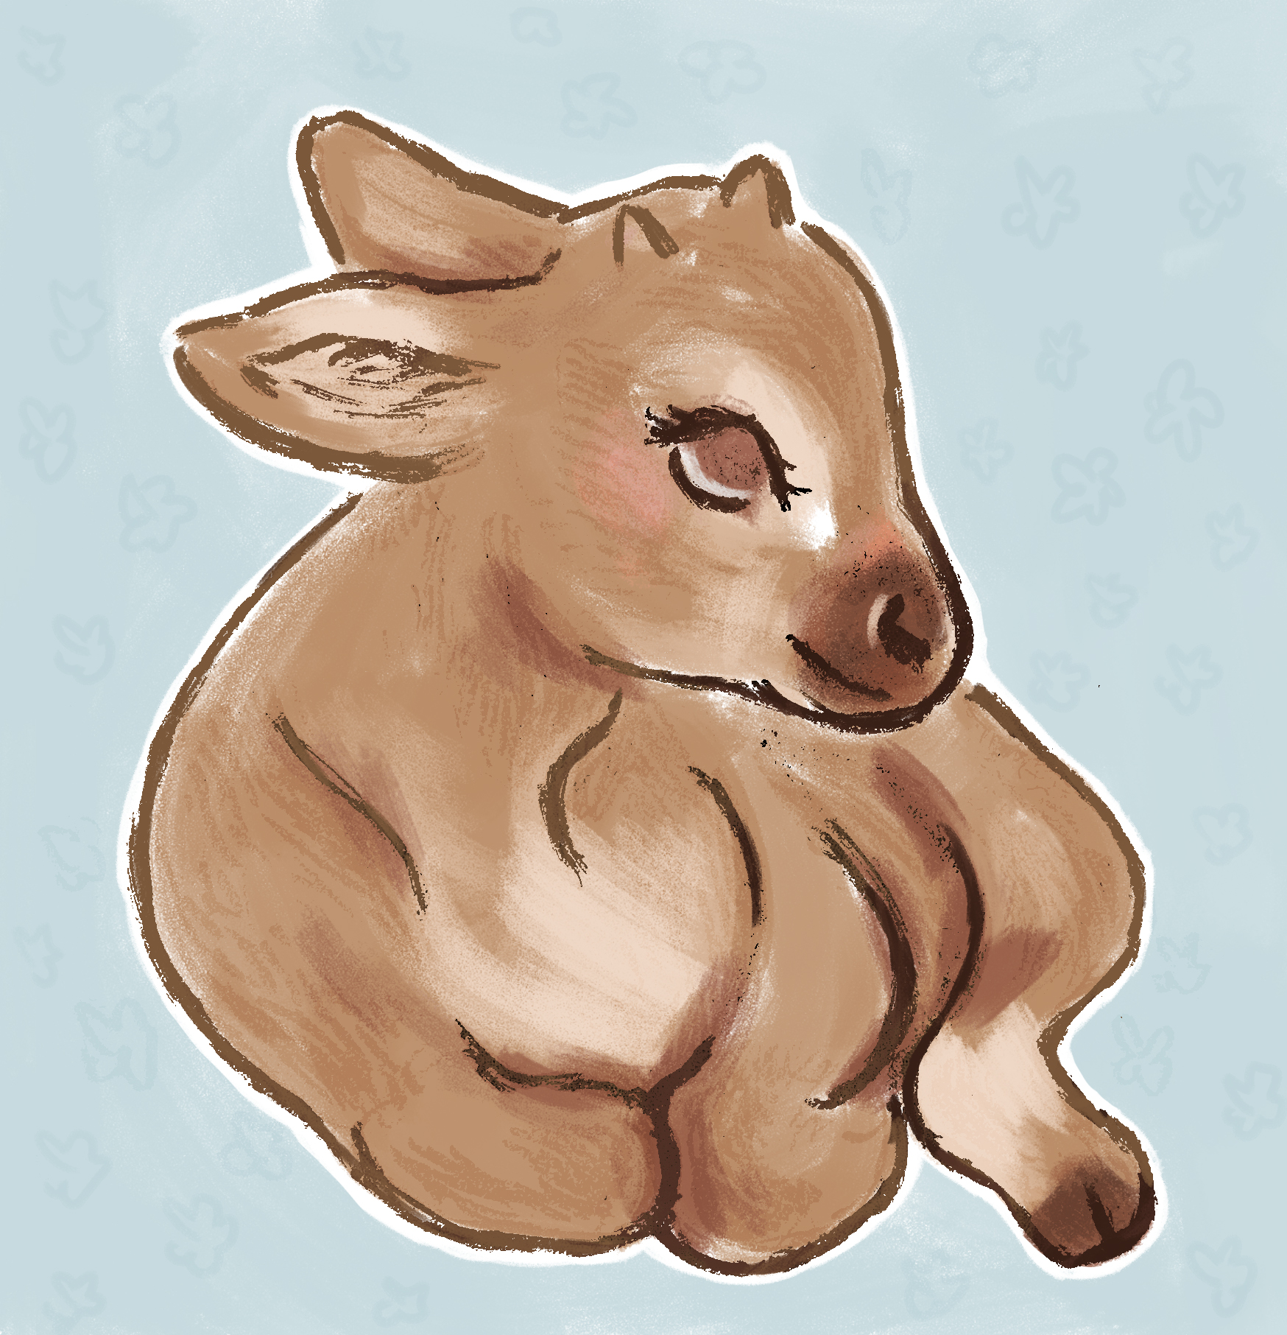

I th Here is some experiment work for my self-promotional project before I went for a more nautical theme. I started using repeating patterns and more stylized brush tools in photoshop.

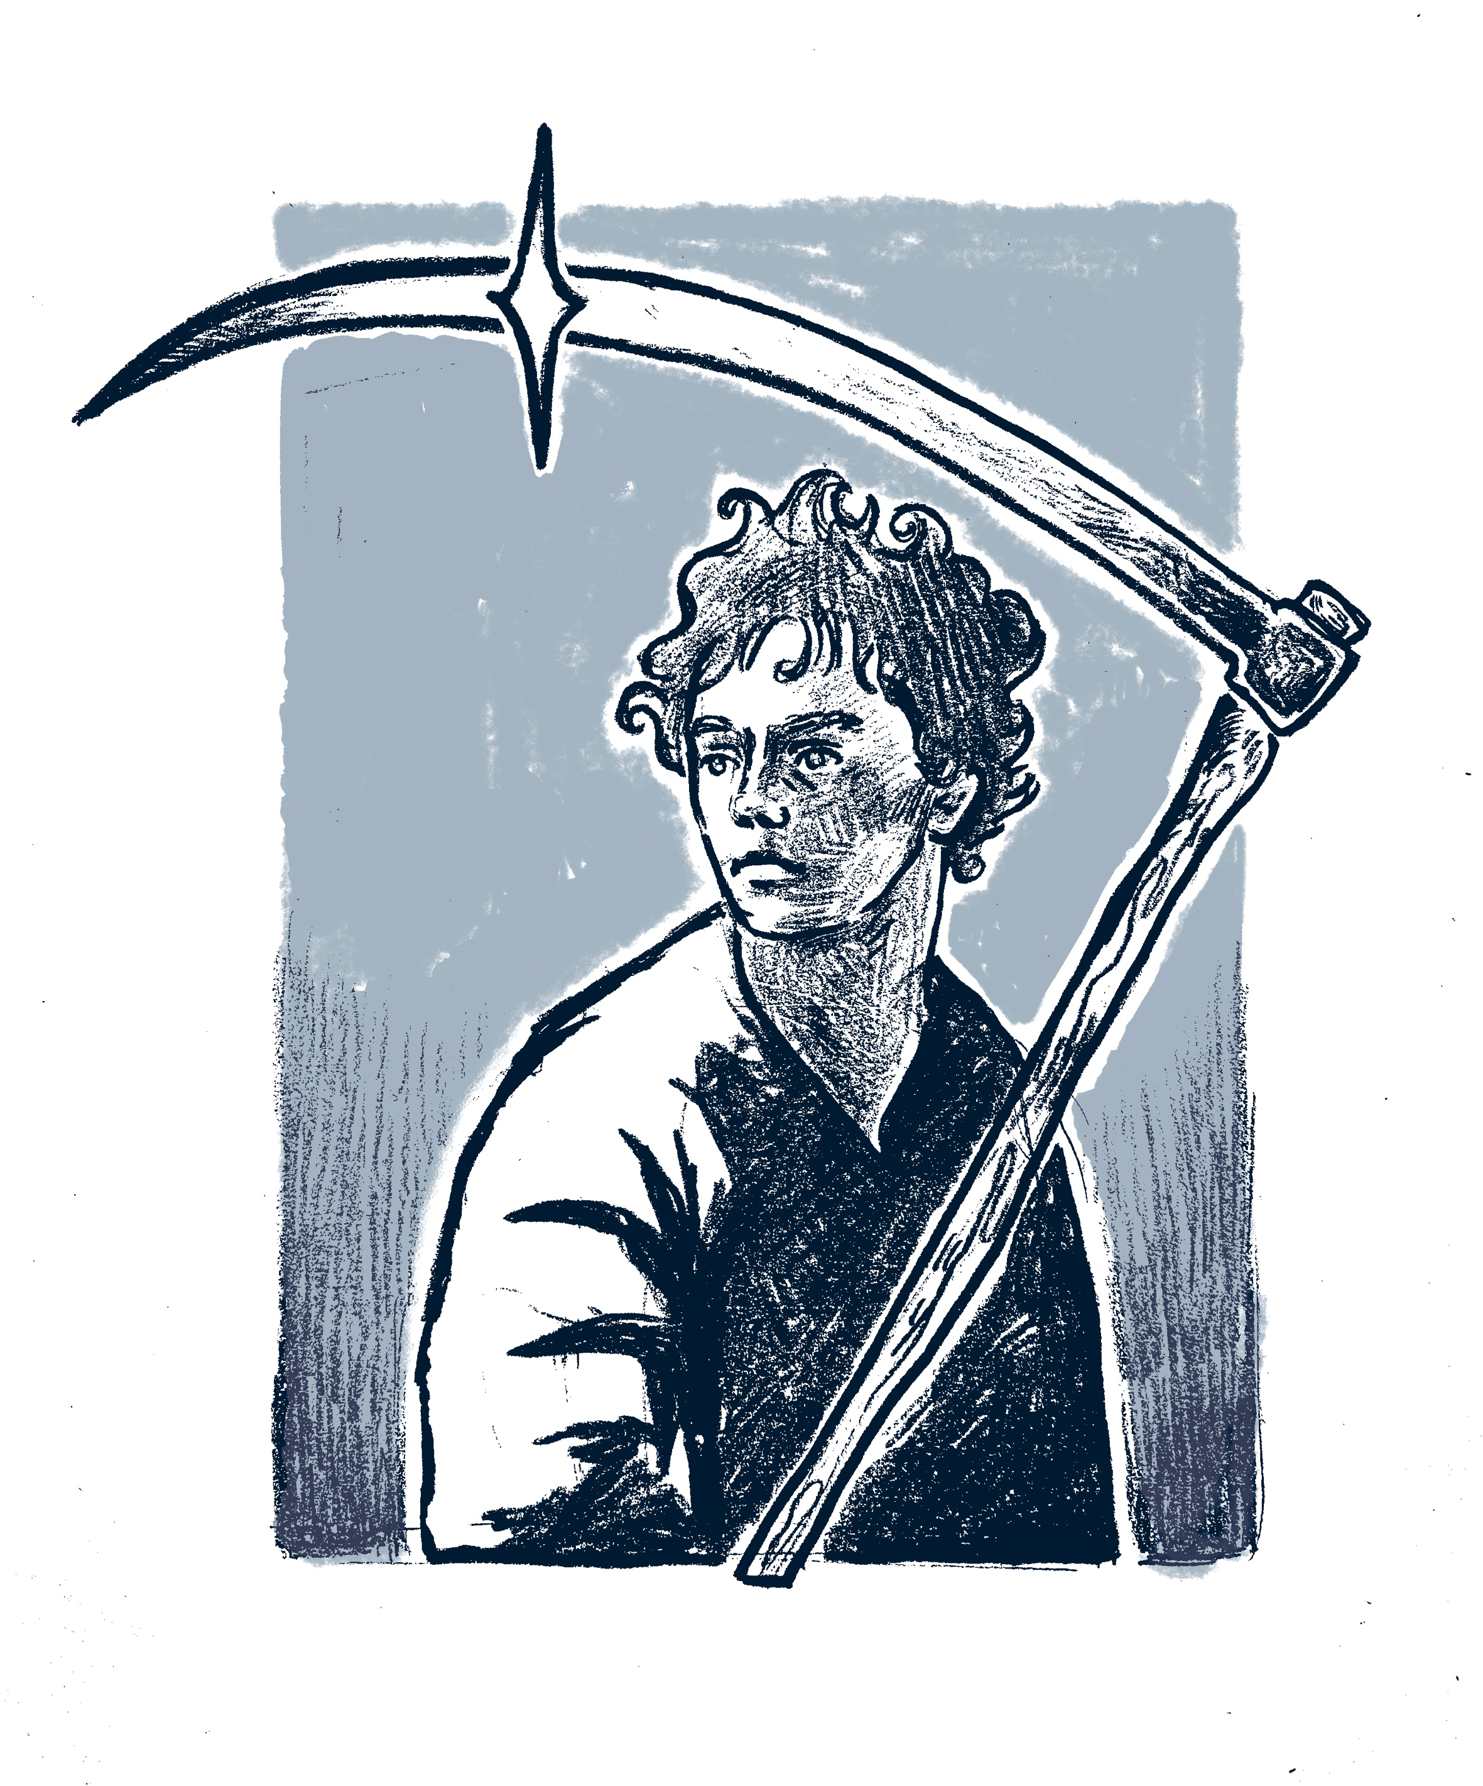

Here is an illustration I created for my summer project in
Which I created a zine, I explored the concept of
Liminality and different methods I could show this. I included
a portrait of a character from one of my favourite books,
being Mort by Terry Pratchett. The books follows the main
character Mort as he becomes deaths apprentice, the
liminality aspect comes from the transition of afterlife, which
is explored heavily in the book, as well as how Mort changes
and grows into himself.
Rochelle Merhet
r.merhet.illustration
Merhet.rochelle@gmail.com
07342201749

